**5.6 Solving Quadrilateral Equations**

*This packet is due on WEDNESDAY DECEMBER 6th and is the Classwork & HW for Monday December 4th and Tuesday December 5th*

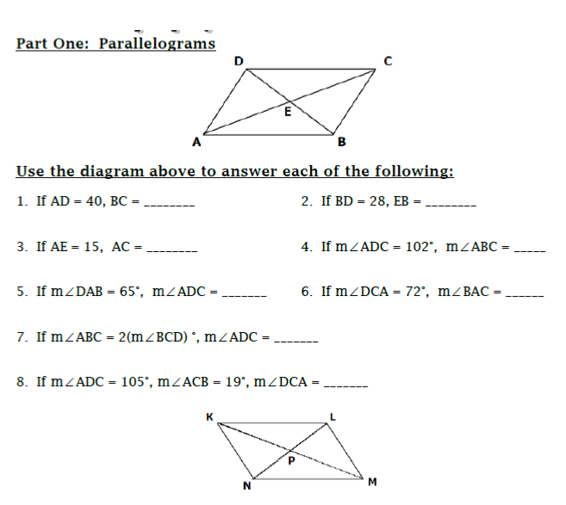

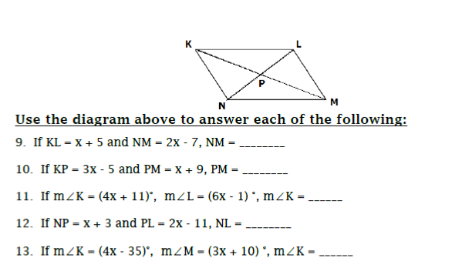

**Workspace:**

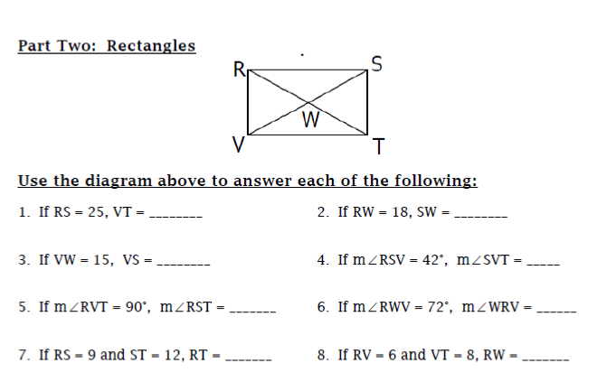

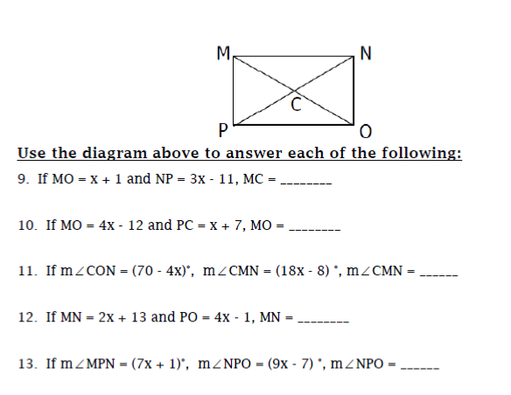

**Workspace:**

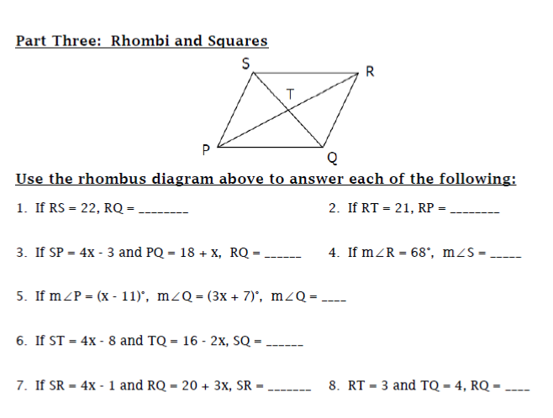

**Workspace:**

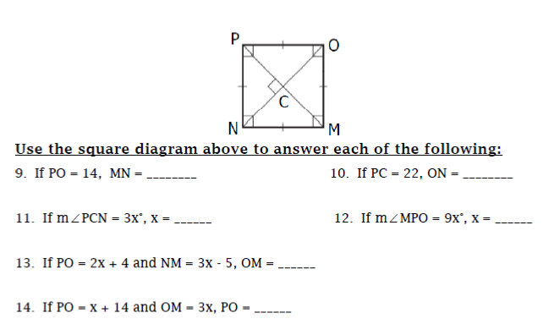

**Workspace:**